Forest Health News
By: Tyler Cooper
July 2019
This article is going to address the Little green/brown metallic beetles that have been annoying us the last few years during the summer months. Japanese Beetles, originally from Japan, first made it to the U.S in 1916 and have been spreading ever since. These insects have a one-year life cycle starting with the eggs that are typically laid in July. Each female beetle can lay up to 60 eggs, these eggs hatch into grubs in August. The grubs will stay underground feeding on grass roots until early to mid-June of the following year when they emerge as adult beetles and start to feed. These beetles will feed on any plant leaf they find palatable. If they taste test a leaf and like their first bite they will put off a floral scent that attracts other beetles until the entire tree/plant is infested. The beetles eat the top layer of the leaf leaving behind a leaf skeleton defoliating the plant .
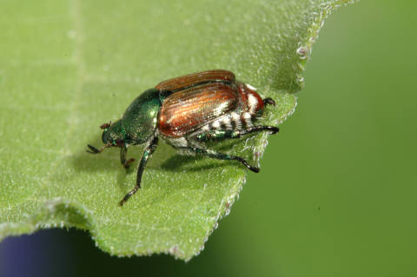
Japanese beetles are known to feed on over 300 different plant species. These infestations typically do not kill a tree, but the defoliation will stress the tree. If multiple years of defoliation occur in a row, death is possible. In drought years it is best to water trees 2-3 times per month if you are concerned with a specific tree. A good rule of thumb is 10 gallons of water per inch of the tree’s diameter. Plants that are in full sun are more targeted than shaded plants, so to prevent major infestations in gardens or other small shrubs, plant in semi-shaded areas if possible.
So, how can you get rid of these pests? There are several different treatment methods, some more tedious than other. One of the most environmentally friendly methods is hand picking in mid to late June. This is exactly what it sounds like, if you spot a Japanese beetle remove it by hand and this will not allow the beetle to release the pheromone that attracts more. Another treatment option would be insecticides, it is important to note that using insecticides is not beneficial to having a pollinator friendly yard and should never be used on flowering plant or trees that will attract bees and other pollinators. That being said there are organic insecticides that contain azadirachtin, Spinosad, or Bacillus thuringiensis galleriae that are effective deterrents for only a few days. Neem oil can be useful in deterring beetles from feeding if applied at the first sight of Japanese beetles. Broad-spectrum insecticides can be purchased at local lawn and garden stores and control Japanese beetles, it is important to check the label and confirm that your tree species and Japanese beetles are listed. Re-application may be necessary depending on weather conditions. Also be aware that these insecticides can kill pollinators so never use on flowing plants or trees. Systemic insecticides are another option but have to be applied as a soil drench in mid-April, but I do not recommend them due to the serious threat to pollinators.
Lastly, DO NOT USE BEETLE TRAPS!! The advertised Japanese beetle traps do nothing but attract more than average amounts of beetles to your property and increase damage to surrounding trees and plants. Just because you see them caught in the trap does not mean that you are solving your problem.
For any questions or concerns regarding forest health please feel free to contact me via email or phone; Tyler Cooper NWTF Area Forester
(816) 586-2061 ext. 113 or tcooper@nwtf.net

