Order Your Spring Seed Here!
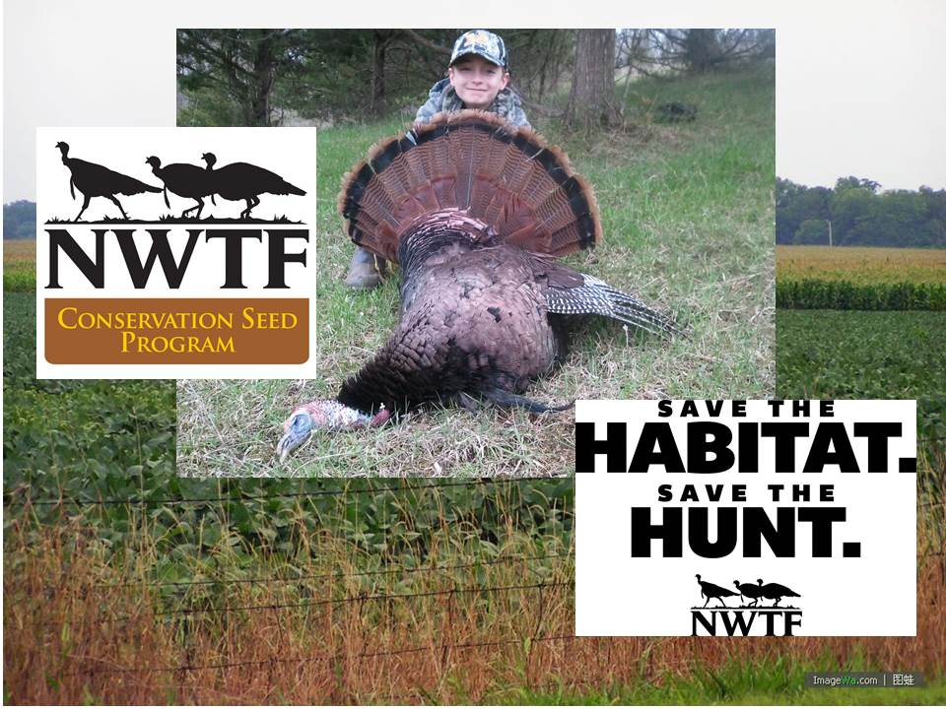
Things to know about our seed program:
- The year-old or older seed that makes our program possible has a germination rate of greater than 60% (most is greater than 80%) or we wouldn’t offer it.
- This is a national program so how much seed we get is dependent upon national supply and demand. Therefore, placing an order only guarantees that you will get the seed IF it becomes available.
- I order based upon past demand and although we MAY have seed available for walk-ins, we will NOT release any seed to folks that have not placed an order until those that did have been served.
- We do not control when the seed gets here but it has always been well within the planting window.
- The delivery locations will be Cape Girardeau, Kirksville, St. Joseph, and St. Peters.
- Seed location coordinators will contact everyone on the list associated with their site once the seed arrives.
- All distribution sites will likely have seed days. The dates and times available for seed pickup will be determined by the coordinators of those sites once the seed arrives. You will be notified of these dates by the coordinators of those sites.
The seed we can most likely count on will be Roundup Ready corn, Roundup Ready soybeans, and milo. The beans left over from last year are Liberty Link. Clearfield sunflowers may or may not be available but we have ordered some for Missouri if they do become available. Same rules apply, you MUST be a member to purchase the seed, it CANNOT be harvested, and the limit on corn is 5 bags per member.
If you are interested in ordering some seed, please fill out the information below and return it to John Burk, 7152 Tomahawk Lane, Steedman MO 65077 or e-mail me the same information to jburk@nwtf.net.
Name____________________________Address______________________________________________Phone Number_____________________e-mail______________________________________________
Number of bags of RR corn (5 bag limit) ____________($35.00/50lb. bag)
Number of bags of sunflower (if available) _____________($35.00/40lb. bag)
Number of bags of RR soybeans _____________($10.00 /50lb. bag)
Number of bags of milo _____________($10.00/50lb. bag)
Please check your preferred pick up location:
Cape Girardeau _____________
Kirksville _____________
St. Joseph _____________
St. Peters _____________

